A TIME AND COST EFFICIENT WEB-BASED JOB RECRUITMENT MANAGEMENT SYSTEM



**Arnold Arisa Gekobe**

**Student ID: 101484**

**An Information System Project 1 documentation submitted to the Faculty of Information Technology in partial fulfilment of the requirements for the award of the Bachelor’s Degree in Business Information Technology of   
Strathmore University**

**Faculty of Information Technology  
Strathmore University  
Nairobi, Kenya**

**September 2018**

# Declaration

I declare that this work has not been previously submitted and approved for the award of a Bachelor’s degree by this or any other University. To the best of my knowledge and belief, the documentation contains no material previously published or written by another person except where due reference is made in the documentation itself.

Student’s signature:

………………………………….………….. [*Signature*]

………………………………….………….. [*Date*]

**Approval**

The Information System Project 1 documentation of Arnold Arisa was reviewed and approved *(for examination)* by:

Supervisor’s signature:

………………………………….………….. [*Signature*]

………………………………….………….. [*Date*]

# Abstract

Employment is a means to an end in today’s society. It is essential so as to ensure survival. The current recruitment process for many organizations in Kenya is made up of a rather lengthy process from advertising to application to evaluation of resumes to interviews and finally hiring. This process is however challenged by the fact that the process is lengthy and often leads to high overhead costs incurred during advertising among other sectors. The Application Management System tries to reduce factors like cost incurred and time spent during the very crucial exercise. The system takes candidate’s answers from questions selected by the organization and stores them in the database. The system schedules interviews automatically and allows for recorded interviews which are submitted and stored in the database. The system generates reports on the recruitment exercise carried out. The system employs Agile Methodology during development because it reduces risk and allows for easy debugging of code and is adaptable to change. The system is web-based so as to allow for wide coverage of people. According to Kemp ,2018 the number of people using the internet has passed 4 billion. The large demographic provides a suitable playground for the system to be hosted.

TABLE OF CONTENTS

Declaration ii

Abstract iii

LIST OF TABLES: v

LIST OF FIGURES: v

Chapter 1: Introduction 6

1.1 Background 6

1.2 Problem Statement 6

1.3 Aim 6

1.4 Specific Objectives 7

1.5 Justification 7

1.6 Scope and Limitations 7

Chapter 2: Literature Review 8

2.1 Introduction 8

2.2 Job recruitment 8

2.3 Current recruitment process 8

2.3.1 Challenges facing recruitment 9

2.4 System development 10

2.5 System testing 10

Chapter 3: System Development Methodology 11

3.1 Introduction 11

3.2 Agile System Development Methodology 11

3.2.1 Listening 11

3.2.2 Designing 11

3.2.3 Coding 11

3.2.4 Testing 12

3.3 Functional and Non-Functional Requirements 12

3.4 List of Design Diagrams that will be drawn in Chapter 4 12

3.5 List of Development Tools that will be used 12

3.6 Method to be used to test the developed system 12

3.7 Domain of Execution 12

3.8 Proposed Modules and System Architecture 13

Chapter 4: System Analysis and Design 14

Chapter 5: SYSTEM TESTING 18

Chapter 6: Conclusion and Recommendation of Future Work 19

6.1 Conclusion 19

6.2 Recommendation for Future Work 19

References 20

Appendix A: Timeline of Activities 21

Appendix C: User Manual 22

XAMPP INSTALLATION 22

SYSTEM OPERATION 22

6.2.1 Applicant Login 22

6.2.2 Employer Login 22

# LIST OF TABLES:

Table 5.1Test Cases 18

Table 5.2 Results 18

# LIST OF FIGURES:

Figure 2.1A diagram of the recruitment process 8

Figure 3.1 A description of the development modules 13

Figure 4.1 Class Diagram of the Job Recruitment System 14

Figure 4.2 User Interface Diagrams 15

Figure 4.3 Sequence Diagram 16

Figure 4.4 Use Case Diagram 17

# Chapter 1: Introduction

## Background

Job application is a formal request to be considered for a position of regular employment. Job application more so happens after clearing university education or when leaving one job in pursuit of another. Many people stream into organizations to seek jobs, leaving hundreds of resumes that are to be sieved through in the required time. Usually in less time than it would take to go through each one of them carefully and categorically.

Job recruitment has been a burden to organizations. For example, According to Getfive 2018 , Google recieves upto 75,000 resumes every week as well Microsoft receiving 50,000 resumes per week. This is a very large number of resumes to go through in a week and still remain objective. The system geared towards reducing the burden on recruiters and yet remain objective. However, based on research, existing systems have had challenges in social interaction as well as keeping track of chains-of-thought to be used after the shortlisting during the interviews.

## Problem Statement

Many people apply for various advertised positions whether qualified or not. This has caused many people to lose on jobs they are very much qualified for. A vacancy can be advertised a week before the spot is to be filled and as such many people line up to bring in their applications. The human resource team is burdened with the task of sieving through hundreds of resumes before settling on the required number as per the vacancy. Many times people are in a hurry so as beat deadlines which is not a really accurate way of recruitment as many people who maybe qualified miss out on the jobs due to being misfortunate enough not to be selected as they may have been overlooked because the recruiters did not have enough time to go through the whole lot of resumes.

## Aim

The system is designed to reduce the time used in the reviewing of resumes by significantly as the system employs use of algorithms to sieve through the data provided by applicants as well as the cost incurred in the recruitment process. This makes the process efficient hence faster and reliable.

## Specific Objectives

1. To review the current recruitment process
2. To identify the challenges facing the recruitment process
3. To develop a system that makes the recruitment process efficient
4. To test the system developed using a sample organization

## Justification

During the job recruitment process many resumes are submitted which have to be sieved through while remaining as objective as possible and using the shortest time possible. Organizations such as Microsoft receive up to 50,000 resumes in a week. The job recruitment management system would come in handy during the reviewing of the resumes

This should all be done with minimal strain on the available organizational resources while using as little time as possible.

## Scope and Limitations

The project is expected to cover all organizations with a human resource team and seek to make the recruitment process speed up by half the time and reduce cost involved in recruitment.

The project maybe slowed down due to slow feedback from stakeholders which ultimately leads to late delivery of the system.

# Literature Review

# 2.1 Introduction

The Application Management System is a system meant to ease the burden of sieving throw thousands of resumes in a bid to hire only the required number of applicants. The system manages the recruitment process and takes into account the unique features that set it apart from other existing systems. The development of the system is aimed at curbing the challenges perceived during the recruitment process and potential remedies.

## 2.2 Job recruitment

Recruitment is the process of acquiring people who are qualified to fill a vacancy advertised by the said organization. This varies from organization to organization due to the difference in the nature of the organization. However, results are always the same.

## Current recruitment process

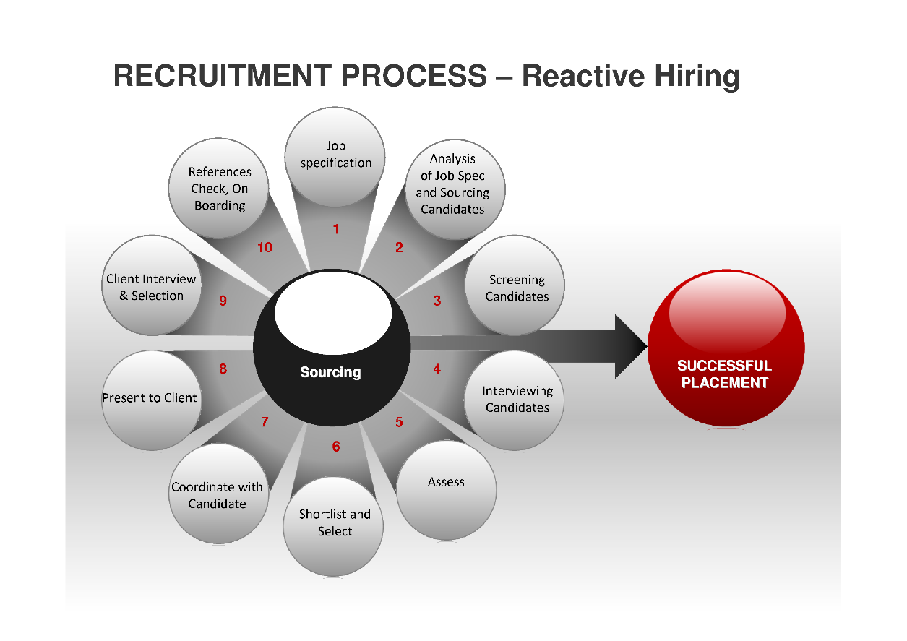

Figure 2.1A diagram of the recruitment process

The current recruitment process entails having an advertisement put up on various platforms at the discretion of the organization. Potential applicants make their application based on the requirements listed in the advertisement. These applicants are required to hand in their applications for vetting. The recruiters review the applications and shortlist potential candidates who are in turn called in for an interview and only the required number of people is selected after the interview (Ideal, 2018).

Organizations like BambooHR and Zohorecruit have moved into online recruitment to help move recruitment to the next level. BambooHR has revolutionized the application process by allowing for Quick reports speedy movement through all the phases involved in the hiring process. It also allows for control of sensitive information like candidates desired salaries. It has functionalities like Job posting from which organizations acquire candidates who are later evaluated. BambooHR reduces hiring cost by close to $8000 per year and the recruiting time by 25%. BambooHR allows for user inputs that are stored in the database and can be retrieved when required. The Human resource department comes up with questions to be asked and the candidates responds to them and response is recorded. The data collected is analysed and reported to provide useful information to the organization. Interview scheduling is conducted in which the calendars are linked via google mail.

The system also ensures communication between organization and the candidate and is mostly via email. (BambooHR, 2018)

Zoho Recruit streamlines candidate sourcing, applicant tracking, interview scheduling, communication and other hiring functions. Zoho Recruit’s pipeline involves screening, client view, interview, and offer and lastly hire. Each module is developed differently. For example Client view is made up of Submitted by client, Approved by Client, Rejected by Client. These groupings make the application process easy as they grouped in regards to the “Client’s” decisions. Candidate information is directly transferred into the client’s database and access to the candidate’s resume is also possible. The system also allows for informed decisions as it provides quick overviews of job status and scheduled interviews. (Zoho Recriut, 2018)

### Challenges facing recruitment

Recruiters are faced by challenges in their day-to-day undertakings which can be alleviated by use an application management system.

Recruiters are burdened with a very large number of resumes to review in a rather limited time. In 2016, 56% of recruiters said they cannot make good hires because of the lengthy procedures involved *(2016 Recruiter & Employer Sentiment Survey MRI Network)*

A huge cost is often incurred during the recruitment process from in-house recruiters to third-party recruiters to travel fees among others. According to (recruiterbox, 2018), an organization may spend $1000 - $5000 on recruitment depending on the nature of the organization which is quite a huge cost on recruitment.

Lack of skilled workers to fill various position for instance in India there was a shortageof software proffesionals who are compitenet and have sufficient knowledge this is according (Agrawal, 2018).

Most companies experience a high turn-over rate which ultimately leads to job vacancies that are to be filled. According to Melany Gallant, 2013 , the average employee turn-over for banking and financing industry was at 17.2%. This causes an almost cyclic pattern resulting in the need for an efficient application management system.

## System development

The system is designed in consideration to the existing open-source system that do not however include location, update of the database after every hire and employee termination. The system includes a smart resume where the applicant answers questions prepared by the organization and the results stored in the database, the system shall also feature tele-conferencing as well as video-upload.

## System testing

The system is to be tested using two approaches, functional testing which shall determine the current state of the system.

Unit tests and integration tests shall also be carried out to determine whether the requirements have been met. Independent components of the system are tested to determine if the system works as designed. This is achieved by using few inputs and a single output.

# System Development Methodology

## Introduction

The system shall apply Object Oriented Analysis and Design owing to the use of java as the programming language which is not supported by the Structured Systems Analysis and Design as it employs use of objects. Processes and data are modelled into real life objects.

The system development methodology of choice is the Agile System Development Methodology. It is most preferred because it allows for frequent releases in short development cycles as well as use of checkpoints at which new requirements can be adopted. The methodology also reduces risks like cost, changing requirements and bugs.

## Agile System Development Methodology

This methodology is particularly fit for use in the development as it allows for stakeholder and user involvement and thus making communication all the more easier. Furthermore, the methodology can apply for all types of organization making it flexible(Smartsheet,2016.)

The methodology will employ extreme programming where development is done in short cycles to allow for incorporation on new requirements. It involves four rather clear steps: Listening, designing, coding, testing

### Listening

This step involves paying keen attention to the requirements and taking note of the little details in the requirements

### Designing

This involves making all the dependencies clear and facilitates easy changing of various parts of the system

### Coding

Code is said to be the only true important thing in a product as without code there is no working product. Coding is the best way of solving problems as it clear and be interpreted in only one way.

### Testing

Conducting unit tests will ensure that every feature works as it should. This is done also by running numerous tests so as to try to ‘break’ the code

Functional tests are also carried out so as to determine the current state of the system.

## Functional and Non-Functional Requirements

The functional and non-functional requirements are to be collected through use of interviews.

## List of Design Diagrams that will be drawn in Chapter 4

Different diagrams shall be employed in the design of the system which are Entity Relation Diagrams (E.R.Ds), Data Flow Diagrams (D.F.Ds), Class Diagrams, Use case diagrams, Sequence diagram and GUI designs of forms.

## List of Development Tools that will be used

Various development tools shall be employed in the development of the system. For instance Java shall be employed as it is a robust language and mature hence very stable and given a large community of users it is easy to find solutions for various errors.

HTML and XHTML shall also be employed as they make web pages viewable by using mark-up tags. MYSQL is the DBMS of choice as it allows for on-demand scalability as well as its high-performance. It is capable maintaining optimum speeds even when receiving millions of queries

## Method to be used to test the developed system

The system is to be tested using two tests; the unit tests and the functional tests. The unit tests test entails carrying out tests to determine whether every feature of the system works as it should. It is also used to try and break the code

Functional tests shall be used to determine the current state of the system as at a given checkpoint. Whether all the functions work as they should.

## Domain of Execution

The system shall be a web-based system as it requires users to access the system from which ever geographical location.

## Proposed Modules and System Architecture

The system shall have three modules being applicant, managerial, recruiter.

The applicant should be able to access the system using a user-friendly graphical user interface as well as have a schema of its own.

The managerial shall be able to view reports developed periodically

The recruiter module allows the recruitment team to view the short-listed candidates as well as being able to contact them. The recruiter shall be able to also add new staff into the system, update data of existing staff or delete information of a terminated staff member.

Figure 3.1 A description of the development modules

Applicant

Smart Resume

Recruiters

Results Page

Questions

Database

Manager’s Report

# System Analysis and Design

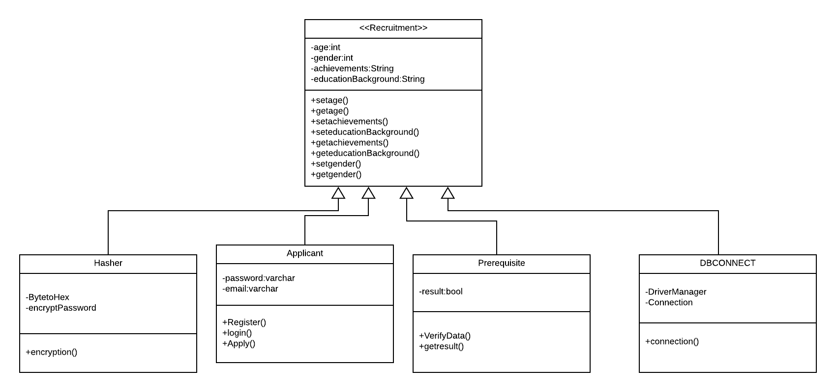

Figure 4.1 Class Diagram of the Job Recruitment System

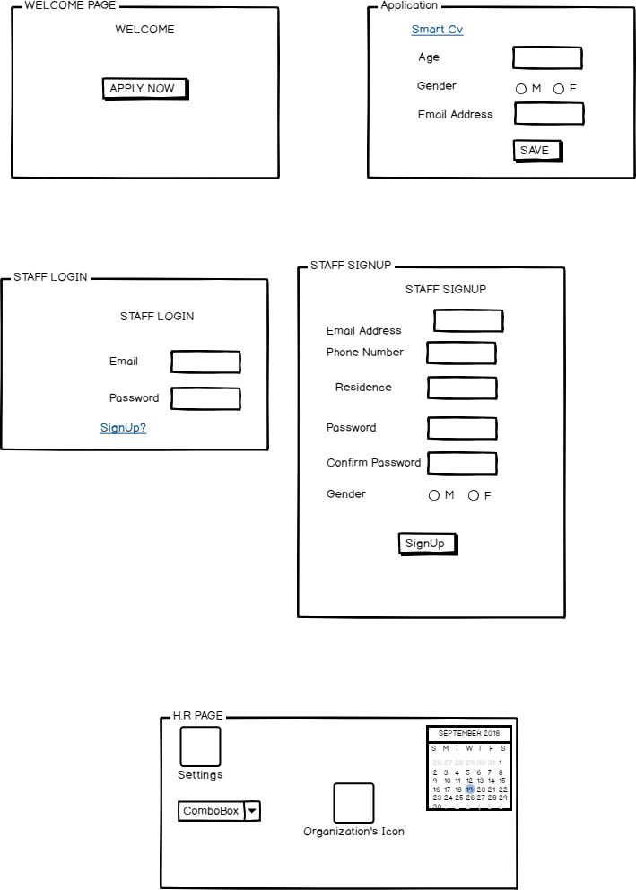

Figure 4.2 User Interface Diagrams

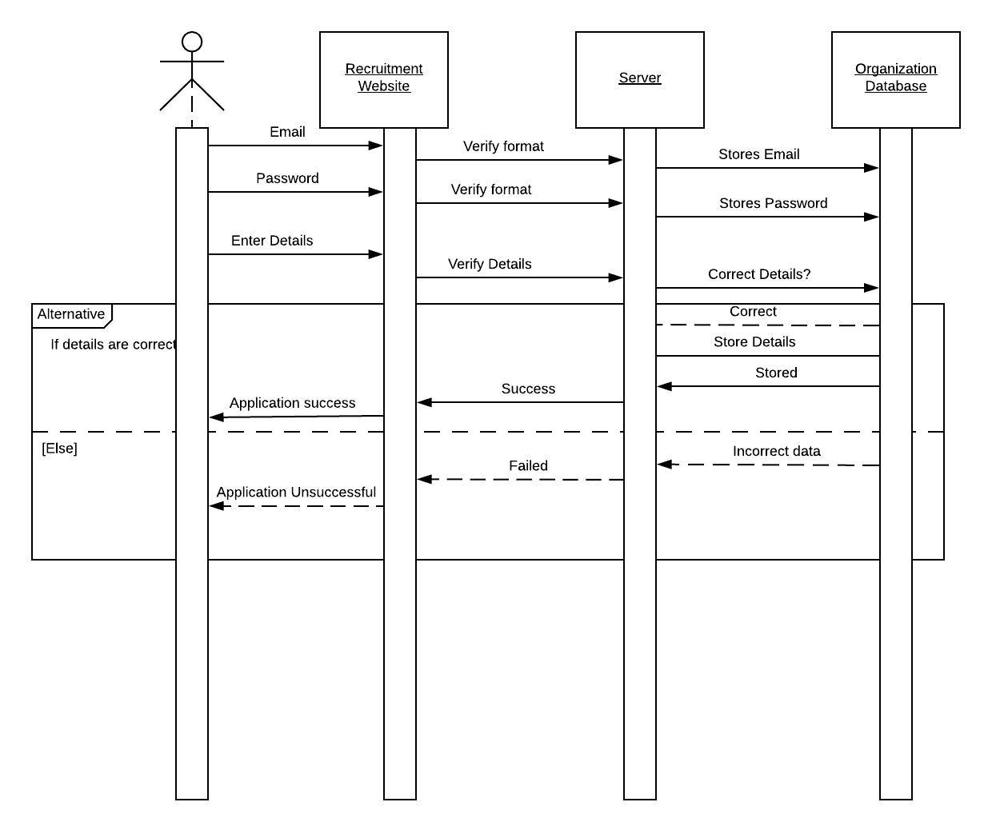

Figure 4.3 Sequence Diagram

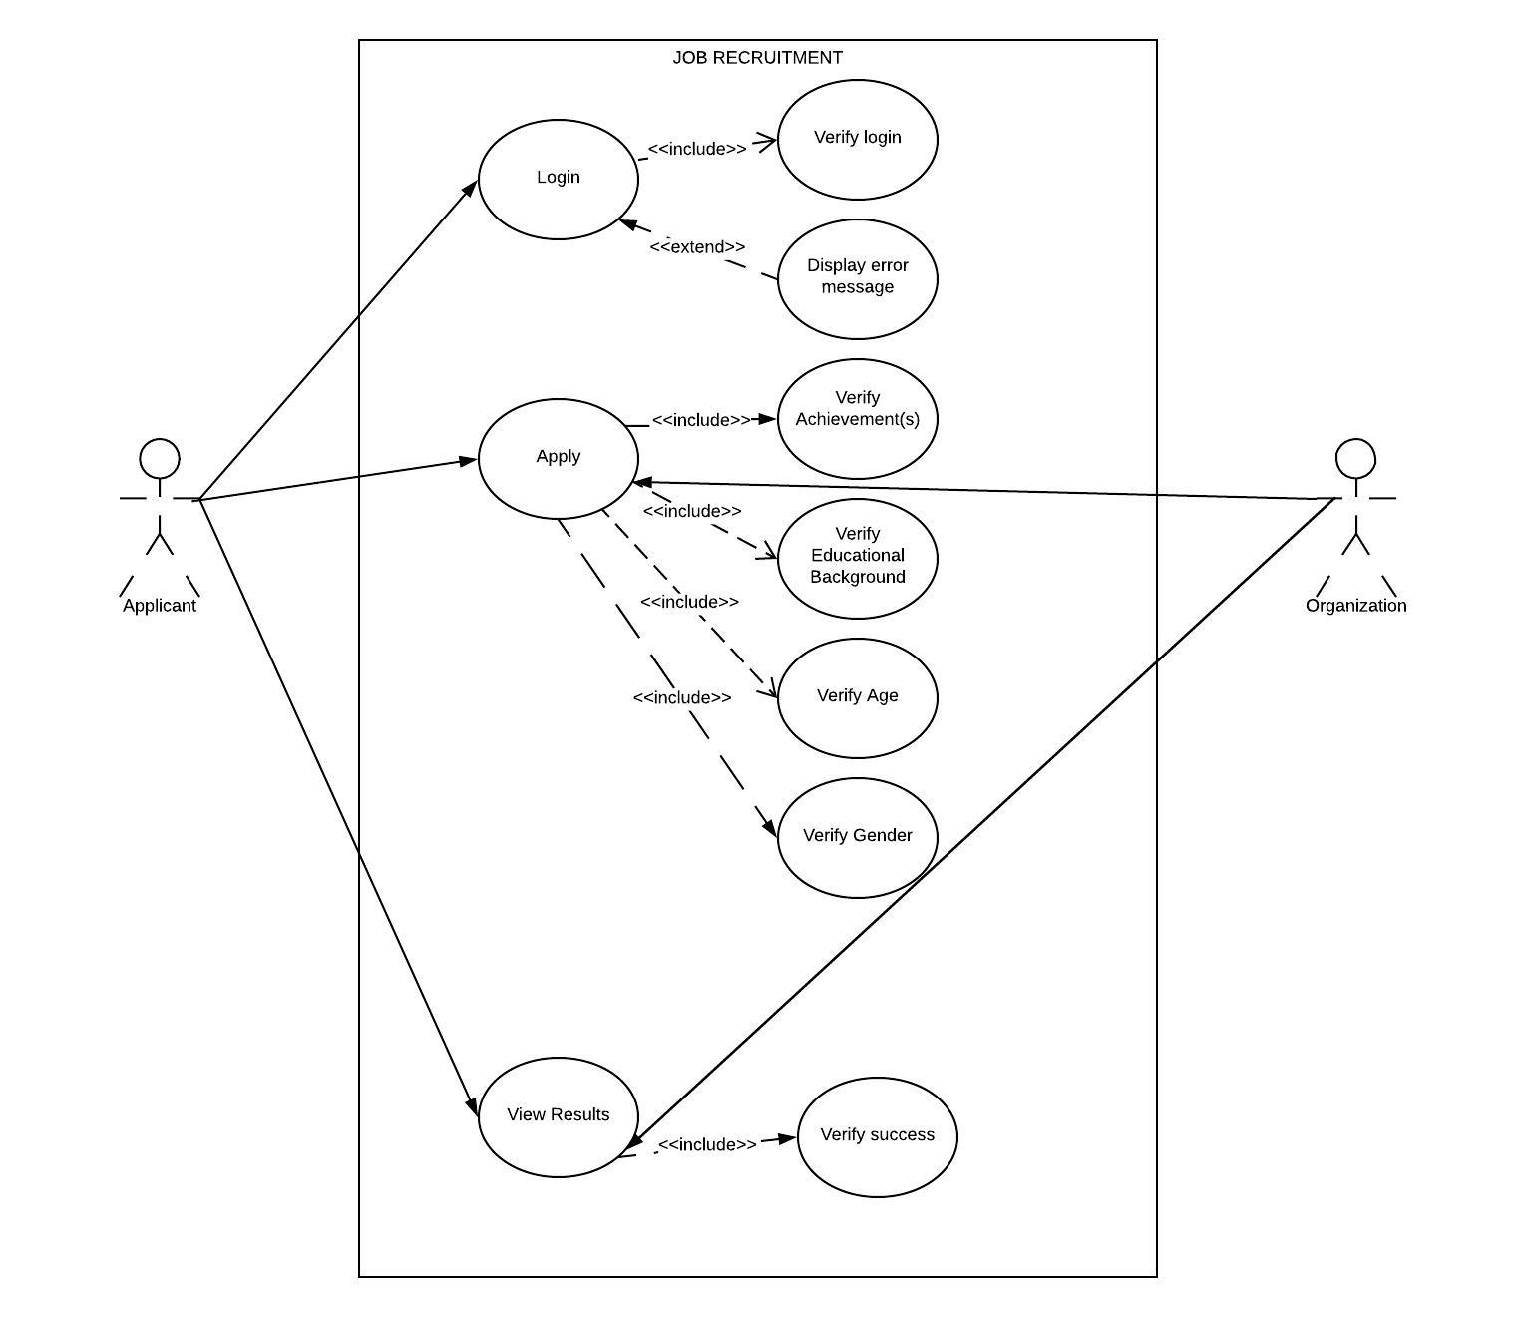

Figure 4.4 Use Case Diagram

FUNCTIONAL REQUIREMENTS

* The system should allow the to user login as well as authentication.
* The system should accept applicant’s details and store them.
* The system should check if the applicant is qualified.

NON-FUNCTIONAL REQUIREMENTS

* The system is to be a web-based application
* The system is to generate periodical reports
* The system should be secure

# SYSTEM TESTING

Table 5.1Test Cases

|  |  |  |  |  |  |
| --- | --- | --- | --- | --- | --- |
| TEST ID | RELATED REQUIREMENT | INSPECTION CHECK | PRE-CONDITION | TEST DATA | PRIORITY LEVEL |
| T1 | FRQ1 | Does the system allow registration? | Users have entered data | Email:  Password: | High |
| T2 | FRQ2 | Does the system store data? | Users should have submitted data | Email:  Password: | High |
| T3 | FRQ3 | Does the system check qualification of applicant? | Validating data entered | Education background | High |
| T4 | NFRQ1 | The system is web-based | Application accessed through the web-browser | Chrome Browser | High |
| T5 | NFRQ2 | Does the system generate reports? | Reports should be generated | Displaying number of applicants | Low |
| T6 | NFRQ3 | Is the system secure? | Can unregistered users access the system? | Email:  Password: | High |

Table 5.2 Results

|  |  |  |  |
| --- | --- | --- | --- |
| TEST ID | EXPECTED RESULTS | ACTUAL RESULTS | STATUS |
| T1 | The user is registered into the system | The user is registered | PASSED |
| T2 | The user data is stored in the system | User data is stored in the database | PASSED |
| T3 | User is notified of the status | User is not notified of the status | FAILED |
| T4 | The system runs on Chrome browser | The system runs on chrome browser | PASSED |
| T5 | Reports are generated | Reports are not generated | FAILED |
| T6 | Unregistered users cannot access the system | Unregistered users cannot access the system | PASSED |

# Conclusion and Recommendation of Future Work

## Conclusion

In the job market there are applicants and recruiters. Many applicants apply for various positions in an organization. The recruitment system is meant to ease the process by reducing the time required to sort the various resumes submitted. The use of Agile methodology was especially beneficial as it allowed for user involvement and as such changes were easily integrated. The system was developed using an Object Oriented Approach and employed use of java language for development. The methodology was particularly helpful in requirements specification. Functional and non-functional tests were run to ensure system integrity.

## Recommendation for Future Work

The modules not developed include:

1. Communication module. This module allows for communication between interviewer and interviewee
2. Scheduling module. This will allow for proper planning and scheduling of interviews and meetings for both interviewer and interviewee

# 

# References

Agrawal, N. M. (2018). *Managing growth: Human resource management challenges facing the Indian software industry*. Retrieved from Science Direct: https://www.sciencedirect.com/science/article/pii/S1090951611000289

BambooHR. (2018). Retrieved from Applicant Tracking System: https://www.bamboohr.com/applicant-tracking/

GETFIVE. (2018, July 23). *Eye-Opening Facts You Must Know About Applicant Tracking Systems (ATS)*. Retrieved from GETFIVE: https://getfive.com/blog/eye-opening-facts-must-know-applicant-tracking-systems-ats/

recruiterbox. (2018). *recruiterbox*. Retrieved from Cost of Hiring New Employees (infographic): https://recruiterbox.com/blog/the-cost-of-hiring-new-employees-infographic

Recruiterbox. (n.d.). *Cost of hiring new employees infographic*. Retrieved from Recruiterbox: https://recruiterbox.com/blog/the-cost-of-hiring-new-employees-infographic

Smartsheet. (2016). *Understanding the Agile Software Development Lifecycle and Process Workflow.* Retrieved from https://www.smartsheet.com/understanding-agile-software-development-lifecycle-and-process-workflow.

Statista. (2018). *unemployment rate from 2007 to 2017*. Retrieved from Statista:The statistics portal: https://www.statista.com/statistics/808608/unemployment-rate-in-kenya/

Zoho Recriut. (2018). *Zoho Recruit*. Retrieved from Recruitment Process: https://www.zoho.com/recruit/userguide/search-results.html?query=recruitment+processes

# Appendix A: Timeline of Activities

# Appendix C: User Manual

## XAMPP INSTALLATION

For windows 10: <https://www.wikihow.com/Install-XAMPP-for-Windows>

## SYSTEM OPERATION

* Select relevant option

### Applicant Login

* Enter Login details. If you are not registered, click on the sign up link to get registered.
* Enter the requested details and click “APPLY”.

### Employer Login

* Enter Log in details. If you are not registered click the “Sign up” link to move to the registration page.
* Enter the requested details and click “SAVE”.



FACULTY OF INFORMATION TECHNOLOGY

BACHELOR OF BUSINESS INFORMATION TECHNOLOGY

**FINAL DOCUMENTATION MARKING GUIDE**

BBT 2204: IS PROJECT 1

DURATION: August 2018 to November 2018

|  |  |
| --- | --- |
| **Student Number** | **Student Name** |
|  |  |

**Project Title: ___________________________________________________________**

**___________________________________________________________**

**___________________________________________________________**

|  |  |  |  |
| --- | --- | --- | --- |
| Area of assessment | | Potential Score | Actual Score |
| Problem statement and objectives | | **15** |  |
| * Is there a clear identification of a specific problem? * Are the objectives S.M.A.R.T? * Are the objectives developmental (as opposed to consequential or goal-based objectives)? * Are the objectives incremental? * Do the objectives support the achievement of the project’s aim? | |
| Contribution of the project | | **5** |  |
| * Has the significance of the project and justification for undertaking the project been clearly explained? | |
| Literature Review | | **10** |  |
| * Has the objective-literature mapping (Literature Review sections to address each Specific Objective) been done correctly? * Does the literature review analyse what has been done before in relation to the project, what has not been done (the gap), and what the project proposes to do to address the gap? * Has adequate literature been reviewed? | |
| Familiarity with the System Development Methodology (SDM) applied | | **10** |  |
| * Is there a specification of a clear choice between either SSAD or OOAD?   + (If SSAD) Does the SDM portray a sequential process?   + (If OOAD) Does the SDM portray an incremental and iterative process? * Has the choice of the SDM been justified? * Have all the stages of the proposed SDM been fully explained? * Is the SDM proposed appropriate for the project? * Does the project Gantt chart correspond with the proposed SDM? * Is there a description of the method proposed to be used to gather the functional and non-functional requirements? * Is there a complete list and description of all the design diagrams drawn in Chapter 4? *That is, either SSAD-related design diagrams (use case diagram, Level 0 & Level 1 DFD, ERD/EERD, database schema, and GUI designs) or OOAD-related design diagrams (use case diagram, class diagram, sequence diagram, database schema, and GUI designs)* * Has a system architecture diagram been drawn to define the structure, behaviour, and views of the proposed system? | |
| Justification of tools chosen | | **5** |  |
| * Is there an acceptable justification for each tool proposed to be used in the development of the Information System? E.g. choice of IDE, choice of programming language, choice of DBMS, etc. * Has the proposed Information System’s domain of execution (e.g. mobile-based, web-based, desktop application, etc.) been correctly identified and justified? * Is there a logical mapping from the Title, to the objectives, to the Literature Review topics, to the methodology, and lastly to the proposed tools to be used? | |
| Analysis | | **10** |  | |
| * Do the functional and non-functional requirements, specified in the analysis section, support the solution to the problem? | |
| Design (Either SSAD or OOAD without mixing the two approaches) | | **20** |  | |
| Structured System Analysis & Design (SSAD)   1. Is the design approach process-oriented? 2. Is the use case diagram present and correct? 3. Is the DFD (level 0 and level 1) present and correct? 4. Is the ERD or EERD present and correct? 5. Is the database schema present and correct? 6. Are the GUI designs of forms and reports (mockups/wireframes) present and appropriate? | **Object Oriented Analysis and Design (OOAD)**   1. Is the design approach data-oriented? 2. Is the use case diagram present and correct? 3. Is the class diagram present and correct? 4. Is the sequence or activity or state diagram present and correct? – either of the three 5. Is the database schema present and correct? 6. Are the GUI designs of forms and reports (mockups/wireframes) present and appropriate? |
| Information System testing and implementation | | **10** |  | |
| * Are the test cases S.M.A.R.T. and present? * Have all the functional requirements been tested? * Is there a user manual that specifies how to install and use the system? | |
| Conclusion and recommendations for future work | | **5** |  | |
| * Does the conclusion provided highlight the main contributions of the project? * Does the documentation specify opportunities/recommendations to extend/improve the project further? | |
| Academic writing standard and general formatting of documentation | | **10** |  |
| * Is the language standard used relative to the level of learning? * Is the narration style formal and third person in nature? * Has the APA referencing style been correctly applied? * Is there editorial completeness of the documentation? i.e. no spelling mistakes, no typing errors, and no grammatical mistakes * Is the general presentation of the documentation appropriately formatted, organized and neat? | |
| TOTAL | | **100** |  |

**Please provide further feedback for the candidate:**

|  |
| --- |
|  |
|  |
|  |
|  |
|  |
|  |
|  |
|  |
|  |
|  |
|  |
|  |
|  |
|  |
|  |
|  |
|  |
|  |
|  |
|  |
|  |
|  |
|  |
|  |
|  |
|  |
|  |
|  |
|  |
|  |

**Examiner** *(signature)***: _____________________________ Date: _________________**